H.T No
Regulations:
A20

Sreenidhi Institute of Science and Technology
(An Autonomous Institution)
Code No: 8HC12 Date: 19-Feb-2025 (FN)

B.Tech I-Year II- Semester External Examination, February-2025 (Supplementary)
DIFFERENTIAL EQUATIONS & INTEGRAL CALCULUS (CIVIL and ME)

Time: 3 Hours Max.Marks:70

Note: a) No additional answer sheets will be provided.
b) All sub-parts of a question must be answered at one place only, otherwise it will not be valued.
c) Missing data can be assumed suitably.
Bloom's Cognitive Levels of Learning (BCLL)

Remember | L1 | Apply | L3 | Evaluate | L5
Understand | L2 | Analyze | L4 | Create | L6

Part - A Max.Marks:20

Answer all QUESTIONS.

 |  | BCLL | CO(s) | Marks
1 | Define Bernoulli’s differential equation | L1 | CO1 | [2M]
2 | Solve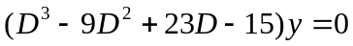 | L1 | CO2 | [2M]
3 | Form the partial differential equation by eliminating an arbitrary function from | L1 | CO3 | [2M]
4 | Classify the partial differential equation 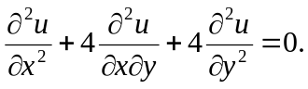 | L2 | CO4 | [2M]
5 | Find | L1 | CO5 | [2M]
6 | Evaluate 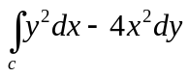along the parabola y=x² from (0,0) to (1,2) . | L1 | CO6 | [2M]
7 | State Newton’s Law of Cooling. | L1 | CO1 | [2M]
8 | Find the complete solution of 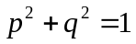 | L1 | CO3 | [2M]
9 | Find 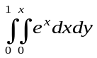 | L1 | CO6 | [2M]
10 | Solve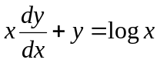 | L3 | CO1 | [2M]

Part – B Max.Marks:50
ANSWER ANY FIVE QUESTIONS. EACH QUESTION CARRIES 10 MARKS.

 |  |  | BCLL | CO(s) | Marks
11. | a) | Solve 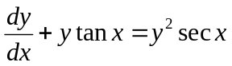 | L3 | CO1 | [5M]
 | b) | A body is originally at 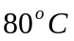 and it cools down to 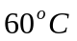 in 20 min. If the temperature of the air is 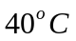,then find the temperature of body after 40min. | L3 | CO1 | [5M]
12. | a) | Solve 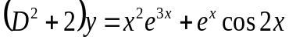 | L3 | CO2 | [5M]
 | b) | Solve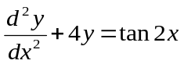 by the method of variation of parameters | L3 | CO2 | [5M]
13. | a) | Solve | L3 | CO3 | [5M]
 | b) | Solve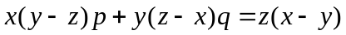 | L3 | CO3 | [5M]
14. |  | Solve 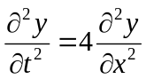 when y(0,t)=0,y(2,t)=0 and  y(x,0)=x-x². | L3 | CO4 | [10M]
15. |  | Evaluate 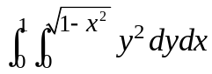by change of order of integration | L5 | CO5 | [10M]
16. |  | Using Gauss divergence theorem, evaluate 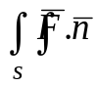ds  where F = xi+yj+zk and S is the cube bounded by  x=0, y=0, z=0, x=a, y=a, z=a. | L5 | CO6 | [10M]
17. | a) | Solve the following differential equations | L3 | CO1 | [5M]
 | b) | Write the procedure of Variation of parameters | L3 | CO2 | [5M]
18. | a) | What are the boundary conditions and initial conditions of one-dimensional Heat equation | L1 | CO4 | [4M]
 | b) | Evaluate | L3 | CO5 | [3M]
 | c) | State Gauss’s divergence theorem | L1 | CO6 | [3M]

-- 00 -- 00 –

